MUZAMMIL SAJAD AHAMED
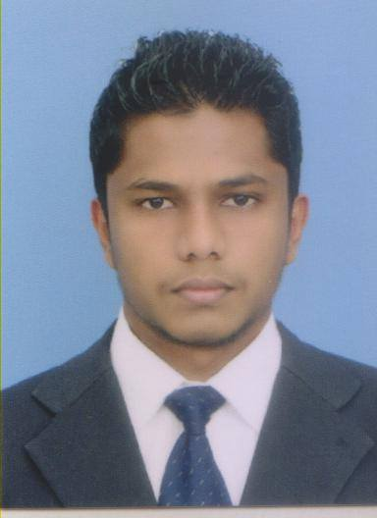

Address: 82,Kandy Road, Warakamura. Ukuwela.
Mobile: +94 755552498
Email: sajad.ahamed@ymail.com
Objectives
To secure a challenging position that could enhance my knowledge and develop my skills in the field of Accounting.
KEY SKILLS
- Efficient analytical, positive thinker and a good communicator.
- Ability to meet the deadlines and make decisions.
- A fast learner with ability to work independently or as part of a team.
- Self motivated and hard working.
Education & QUALIFICATIONS

- Chartered Institute of Management Accountants (CIMA), UK- CIMA Passed Finalist.

- Secondary School Education – (Please refer Annex – 1)

- Certificate in Computer Literature – Microsoft Word, Excel, Power Point.

- Diploma in Desktop Publishing – Adobe Photoshop, Corel Draw, Illustrator, Page Maker.

COMPUTRER LITERATURY

- Sound Knowledge & in Accounting Systems including Tally, Quick books, ACCPAC, MYOB etc.

- Advanced Excel & Word Knowledge. Can handle large number of data.

Special Achievements

- Won the All Island first place in the speech competition consecutively for three years.
- Champion in the Matale District Chess Competition.
Other ACTIVITIES

- Held the position of the Treasurer, than Secretary of the Interact Club of St. Thomas' College, Matale.
- I am the Secretary & Cricket Captain of the Warriors Sports Club-Matale.
- Participated in All Island level Chess Competitions.
- Organised & participatrd in many charitable activities with the support of the school staff & Interact Club.
- Runner-up in the Matale District chess competition.

Language Skills

- English – (oral, writing, reading)
- Sinhala - (oral, writing, reading)
- Tamil - (oral, writing, reading)
- Arabic - (writing, reading)
Personal Details

Age : 22
Date of Birth : 10th October 1991
Gender : Male
Civil Status : Single
Nationality : Sri Lanka
NIC : 912840697V

referees
1. Mr. Mohamed Rikas 2. Mr. Mohamed Rifai
Managing Director, Managing Director,
H.M.S. Distributors (PVT) Ltd, Crown Tire Retreaders (PVT) Ltd,
46, Kandy Road, IDB Industrial Estate,
Warakamura. Kaludewala.
Mobile: +94770870690 . Mobile: +94775338111

I declare on my honor that the particulars I have given above are, to the best of my knowledge and belief, true and accurate.

M.Sajad Ahamed.

Annex - 1

Academic Qualifications

Secondary School Education
Name of school  St. Thomas' College – Matale.  St. Thomas' College – Matale.  St. Thomas' College – Matale. | Year  December 2007  Admission no : 73377430  August 2010  Admission no : 5815509  August 2011  Admission no : 7956584 | Highest examination passed  GCE Ordinary Level  GCE Advanced Level  GCE Advanced Level | Main subjects & grades  English (A)  Social Studies (A)  Agriculture (A)  Islam (A)  Science (B)  Sinhala (B)  Health Science (B)  Mathematics (C)  Art (C)  Biology (C)  Chemistry (S)  Physics (S)  English (C)  Biology (B)  Chemistry (C)  Physics (S)  English (C)

